What is Networking

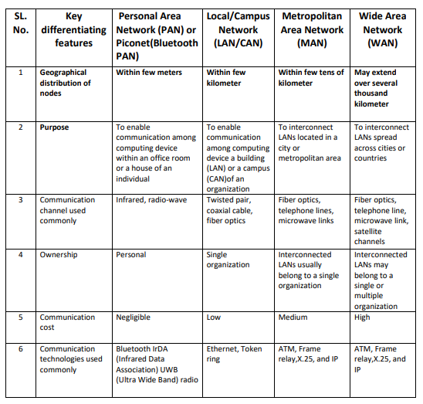  
Networking is a system of exchanging information between two machines. Here is a chart of some of the technologies that the computer has to do this networking

.